Splicing Graph and EST Assembly Problem
Steffen Heber, Max Alekseyev, Sing-Hoi Sze, Haixu Tang and Pavel A. Pevzner
Bioinformatics, Vol. 18, pp. S181-S188, 2002
- Introduction
We abandon the linear (sequence) representation of each transcript and replace it with a graph representation where each transcript corresponds to a path in the graph.
- EST assemblies
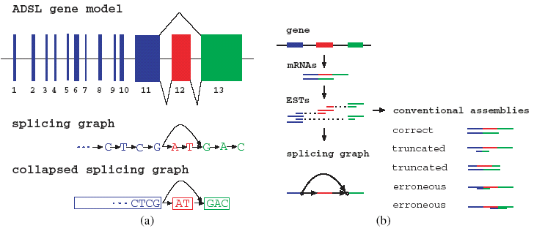
- Error correction
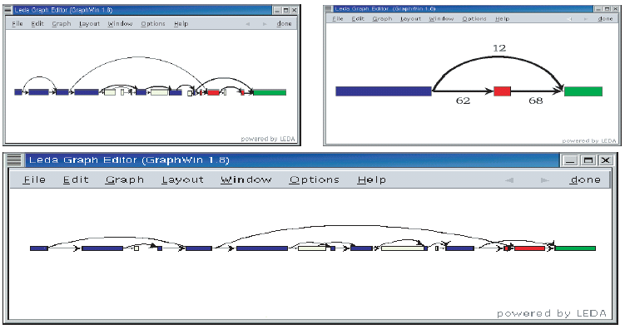
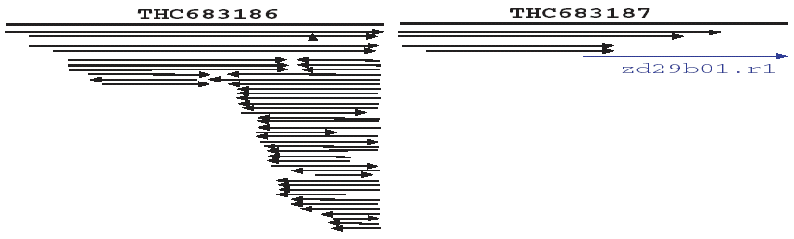
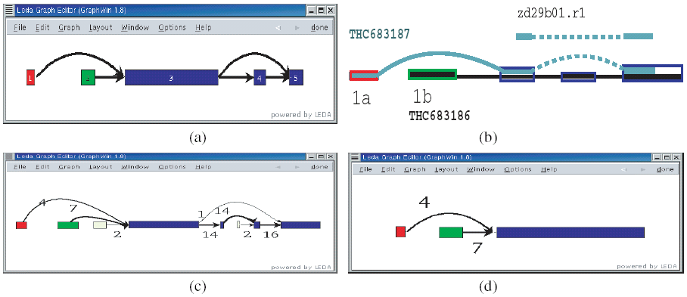
- Result and Discussion
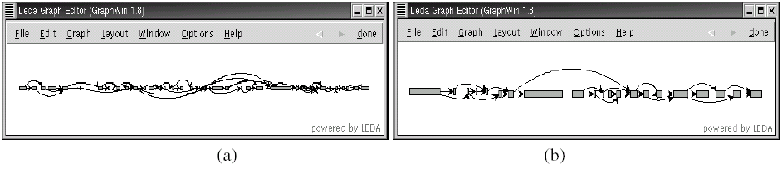
Created by : Jih-Wei Huang
Date : Oct. 25, 2002

